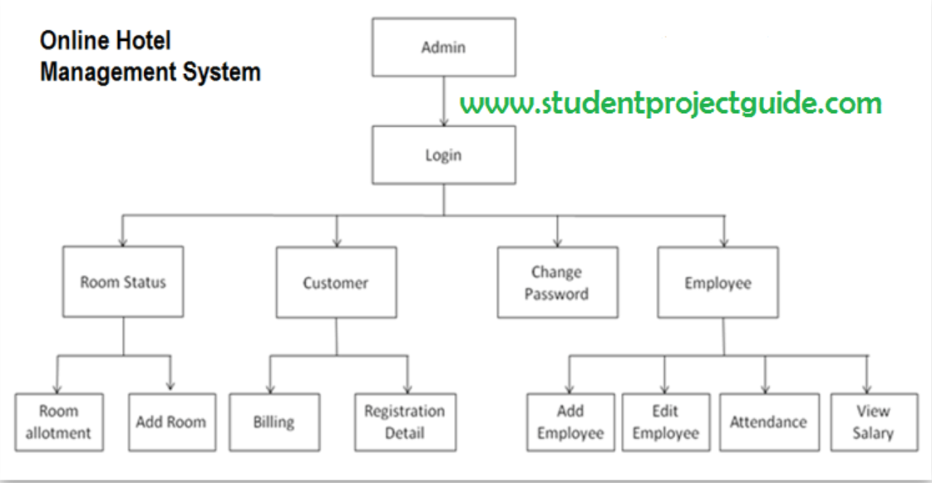

User Stories for Online hotel management application: -

User type Epic User stories

Admin Employee 🡪 As an admin I can add employee.

🡪 As an admin I can edit employee so that we can manage employees.

🡪 As an admin I can view salary of the employees so that we can track

salary

🡪 As an admin I can view employee attendance so that we can track how

many days they are attended.

Room status 🡪 As an admin I can add room so that if any free rooms we can add to our

application

🡪 As an admin I need to know how many rooms allotted so that we can

add free rooms to our application.

customer 🡪 As an admin I need to know the customer billing so that we can track the

billing details

🡪 As an admin I can see registration details of customers so that it’s easy to

identify when they login.